**9th May 2026...The Famous Annunciation Plants Stall!**

This is the perfect time to stock up on young plants for your garden, lovingly cultivated by our intrepid gardening community and sold at very reasonable prices. Perhaps you’ve bought in the past and now have some samples you can donate? They would be welcomed. It will be a great opportunity to hear how last year’s crop got on. We’d love to see some pictures of your successes. Invite friends and neighbours!

**13th** **June 2026... Summertime home spun fun!**

We end our coffee morning programme with a mini summer fair with lovely stalls to browse in the summer sunshine (we hope!!) as well as inside along with a few fun games. If you'd like to have a stall in our mini fair… email Jacqui: [jacquigoddard@mac.com](mailto:jacquigoddard@mac.com) to book your table. (or ring and leave a message at 0208 908 2252)

**11th July 2026... Open Garden at the vicarage!**

**​**We end our coffee morning programme with a Summer Cafe in the vicarage garden next door to the hall. Come and enjoy the garden and relax with friends.

__________________

**Coffee Morning Plus breaks for the month of August. See you on the 11th of September 2026**

The Annunciation at South Kenton

[www.southkentonchurch.org](http://www.southkentonchurch.org)

020 8908 2252

**Coffee mornings Plus**

**At The Annunciation**

**Second Saturdays**

**every month**

**10.00 – 12.00pm**

**2025 - 2026**

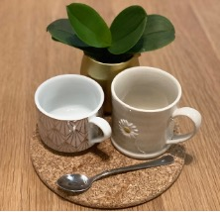

*Welcome to our Coffee Morning Plus Programme.*

*As always, over the coming year we will get together with our friends and neighbours for a chat over free drinks and homemade cakes in our church hall on the corner of Windermere Ave and Carlton Ave East, on the* ***second Saturday of every month (apart from August!)***

*Each month there is an added interest to the morning while we’re enjoying ourselves, but with no obligation to join in if you’d rather just have a natter. Conversation staves off loneliness, creates friendship and brings joy. Have a browse through the programme inside and make a date each month to come and enjoy yourself. Why not invite your neighbour too. We are looking forward to welcoming you!*



**​**

**13th September 2025…Welcome back!**

Welcome back to our Saturday morning coffee club! This coffee morning is a chance to catch up and swap summer stories and remind ourselves of why it’s good to get together over a cuppa and a slice of the vicar’s lemon drizzle.

**11th October 2025…Seasonal card making for Diwali, Hanukkah & Christmas!**

Our communities have lots of celebrations to plan for at this time of year. In a time when our world seems to be reinforcing a disconnect from one another, why not make your Hindu, Jewish or Christian neighbours a card to share in their season of joy!

**8th November 2025…Remembering…Quiz Saturday**

‘We will remember them’… As remembrance Sunday is on the 9th  of November this year we will focus on hope and have a ‘prayer for peace corner available for all who would like to contribute. These prayers will be used as part of our prayer time in our Sunday service. We will also have a fun Quiz to jog our memories ☺.

**13th December 2025... Christmas Market**

Join us for coffee and some Christmas bargains at our mini Christmas Market . If you'd like to have a stall in our Christmas Market email Jacqui: [jacquigoddard@mac.com](mailto:jacquigoddard@mac.com) to book your table. (or ring and leave a message at 0208 908 2252)

**Before you leave us on that day why not take the opportunity to experience our Labyrinth prayer walk …** a space that welcomes everyone whatever faith or none, there is something for you. make sure you pop over to spend some quality time in the peace and tranquillity of our little church. It is the season of Advent, and the church will be reflecting our time of waiting, getting ready to celebrate Christmas. Carols will be playing, and we pray this prayer-filled space will offer much comfort and joy!

**10th January 2026... Recycling calendars into cards!**

Can’t wait to share a nifty way to recycle your picture calendar. So, bring your old calendar along and see how quickly you can turn it into something new and very useful

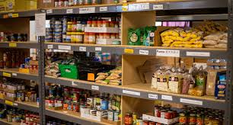**14th February 2026... Love is…supporting your foodbank.**

With a strong notion of love in the air, what better time than to focus on ‘loving your neighbour as yourself’. We’re going to focus on our local foodbanks, where they are and how we can help so many in desperate need of this support.

**14th March 2026…** **Tabletop quiz morning**

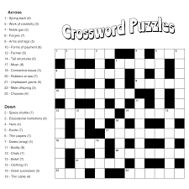How’s your general knowledge? There will be simple crosswords, but also a host of other puzzles you might enjoy having a go at if you’re in the mood. Doing a puzzle with a group of friends is often so much more fun too and you can help each other succeed.

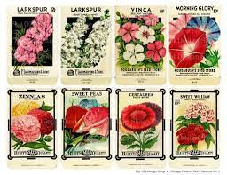**11th April 2026...It’s Springtime and that means seed swap time and homemade bird feeders!**

Have you got some spare seeds you’re happy to give away so others can have a go at growing them? We can tell you how to grow them. Some you can just scatter! We will also be making our own bird feeders after they were so successful last year! There is film footage to share!