8th May 2027...The Famous Annunciation Plants Stall!
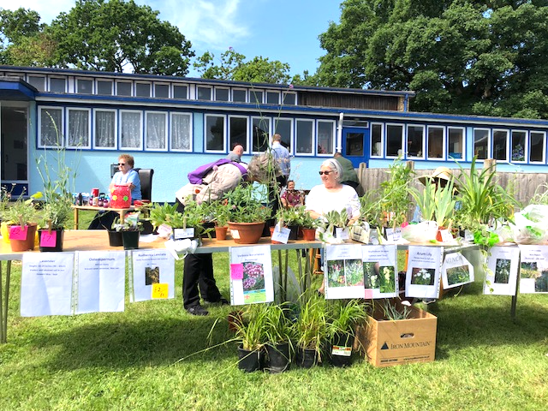
This is the perfect time to stock up on young plants for your garden, lovingly cultivated by our intrepid gardening community and sold at very reasonable prices. Perhaps you’ve bought in the past and now have some samples you can donate? They would be welcomed. It will be a great opportunity to hear how last year’s crop got on. We’d love to see some pictures of your successes. Invite friends and neighbours!

12th June 2027... Summertime home spun fun!
We welcome June with a mini summer fair with lovely stalls to browse in the summer sunshine (we hope!!) as well as inside along with a few fun games. If you'd like to have a stall in our mini fair email Jacqui: jacquigoddard@mac.com to book your table. (or ring and leave a message at 0208 908 2252)
10th July 2027... Open Garden at the vicarage!
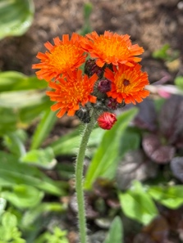
​A resounding success last year means once again we will end our coffee morning programme with a Summer Cafe in the vicarage garden next door to the hall. Come and enjoy the garden and relax with friends.
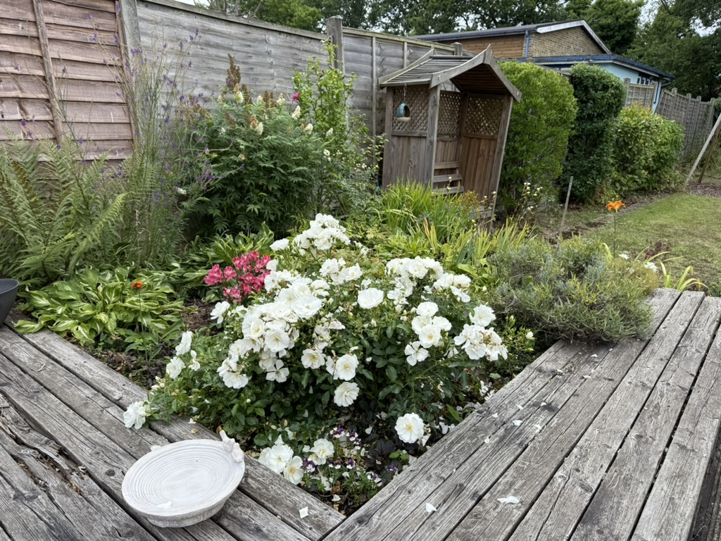
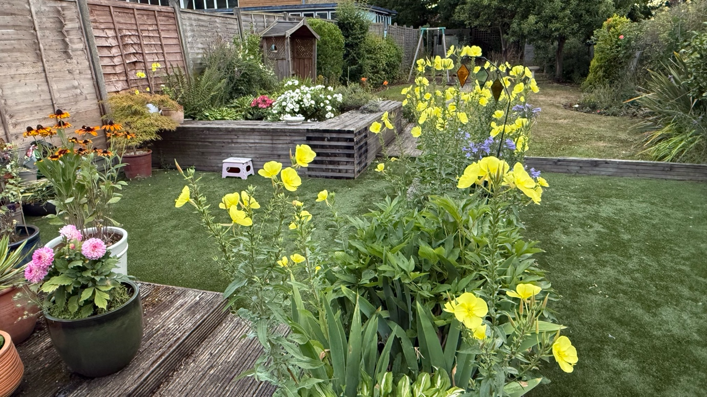
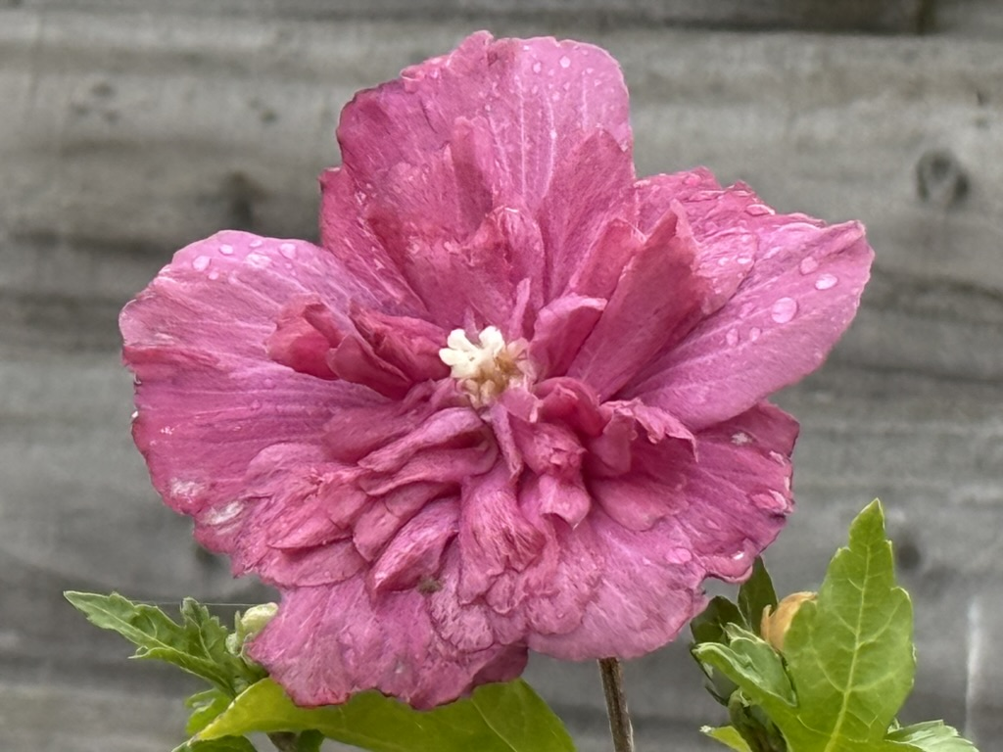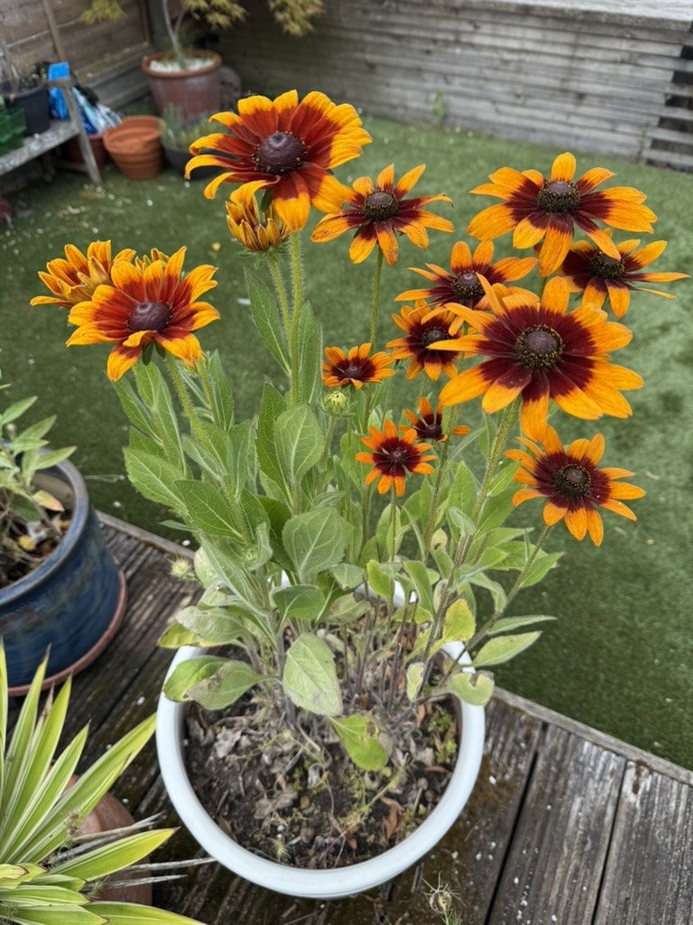

__________________
Coffee Morning Plus breaks for the month of August. See you on the 11th of September 2027
The Annunciation at South Kenton
www.southkentonchurch.org
020 8908 2252

Coffee mornings Plus
At The Annunciation
Second Saturdays
every month
10.00 – 12.00pm
2026 - 2027

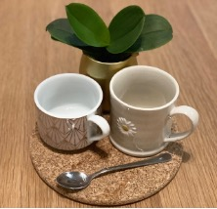

Welcome to our Coffee Morning Plus Programme.

As always, over the coming year we will get together with our friends and neighbours for a chat over free drinks and homemade cakes in our church hall on the corner of Windermere Ave and Carlton Ave East, on the second Saturday of every month (apart from August!)

Each month an added interest adds to the fun, but there’s no obligation to join in if you’d rather just have a natter. Conversation staves off loneliness, creates friendship and lifts our spirits. Have a browse through the programme inside and make a date each month to come and enjoy yourself. Why not invite your neighbour too. We are looking forward to welcoming you!


​
12th September 2026…Welcome back!
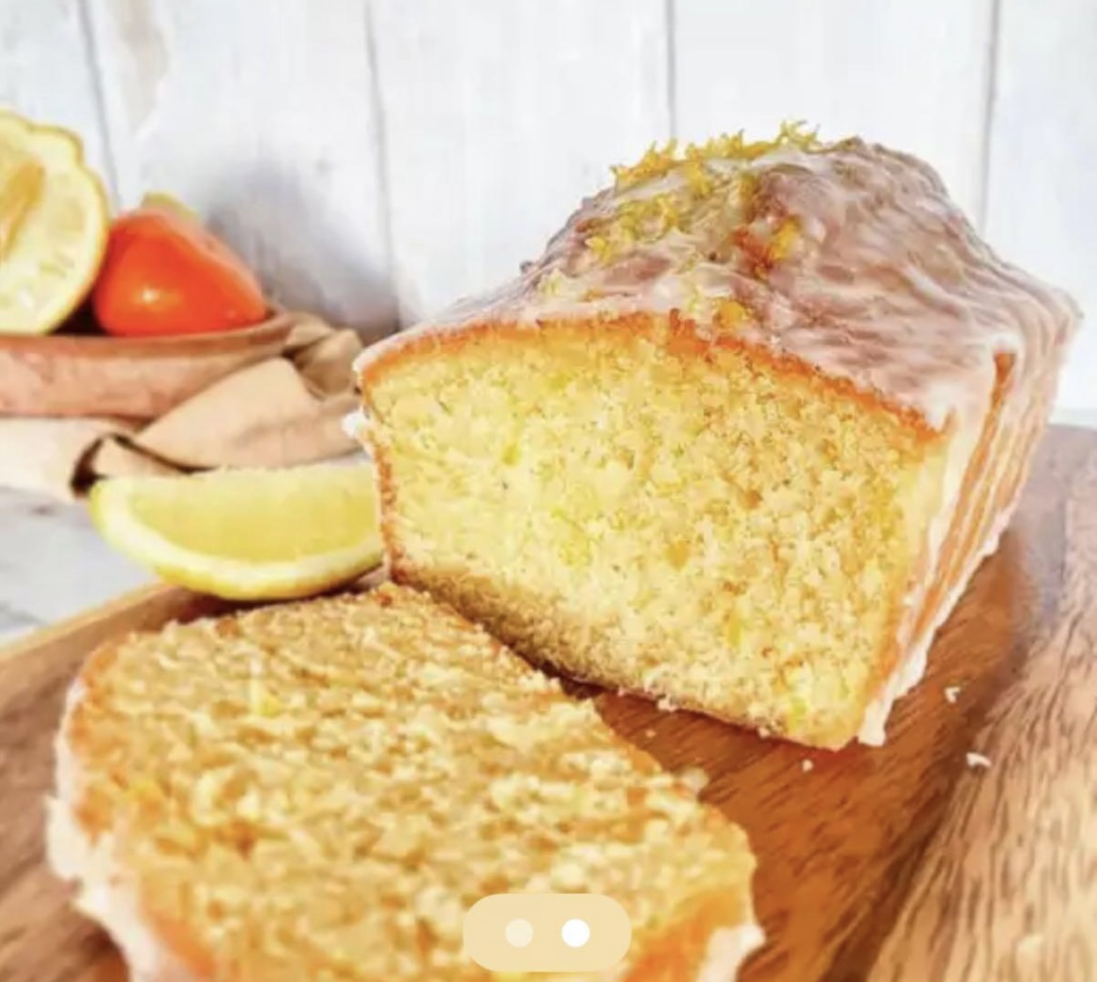
Welcome back to our Saturday morning coffee club! This coffee morning is a chance to catch up and swap summer stories and remind ourselves of why it’s good to get together over a cuppa and a slice of the vicar’s lemon drizzle.
10th October 2026…Book and magazine swap
Any books you really loved or magazines you’d forgotten to let go of that you think others might enjoy? Bring them along and share the joy (but please take them back with you if they don’t find a new home )

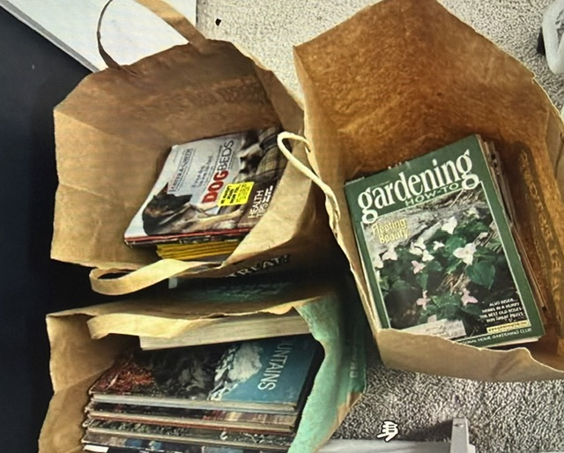

14th November 2026… Seasonal card making for Diwali, Hanukkah & Christmas!


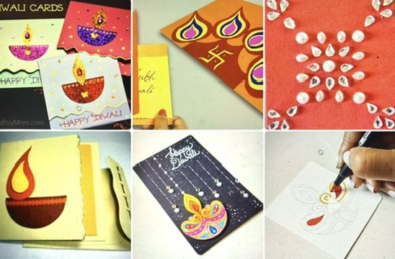
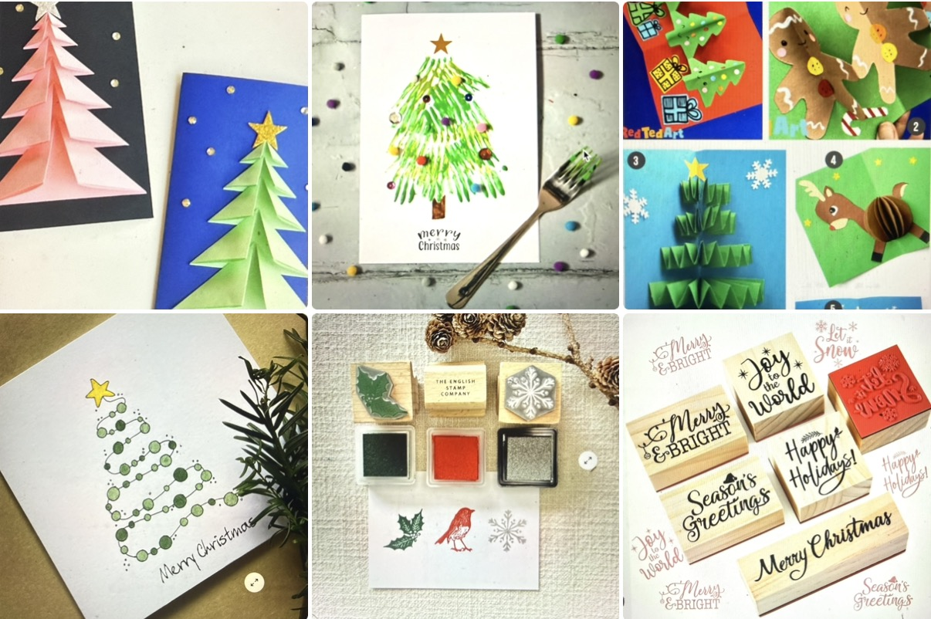

Our communities have lots of celebrations to plan for at this time of year. In a time when our world seems to be reinforcing a disconnect from one another, why not make your Hindu, Jewish or Christian neighbours a card to share in their season of joy!

12th December 2026... Mini Christmas Market
Join us for our Mini Christmas Market. If you'd like to have a stall in our Christmas Market email Jacqui: jacquigoddard@mac.com to book your table. (or ring and leave a message at 0208 908 2252)
Before you leave us on that day why not take the opportunity to experience our Labyrinth prayer walk … a space that welcomes everyone whatever faith or none. So make sure you pop over to spend some quality time this season of Advent in the peace and tranquillity of our little church. Carols will be playing, and we pray this prayer-filled space will offer much comfort and joy!
9th January 2027... Recycling calendars into cards!
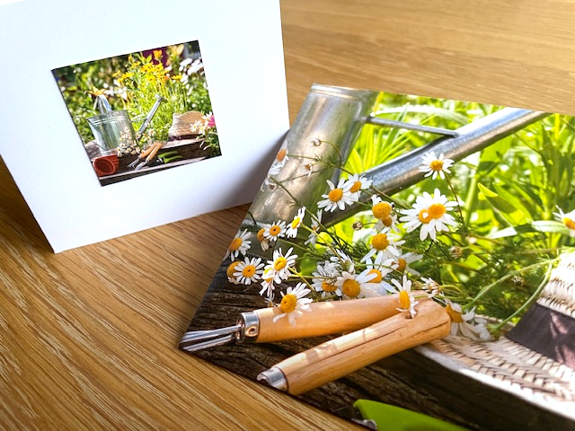
Here it comes again! A nifty way to recycle your picture calendar each year. So, bring your old calendar along and see how quickly you can turn it into something new and very useful.


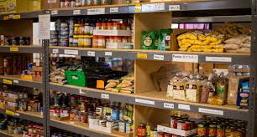
13th February 2027... Love is…supporting your foodbank.
With a strong notion of love in the air, what better time than to focus on ‘loving your neighbour as yourself’. Bring something along and we’ll share it with one of the local foodbanks in the area.

13th March 2027…Time to make our homemade bird feeders!
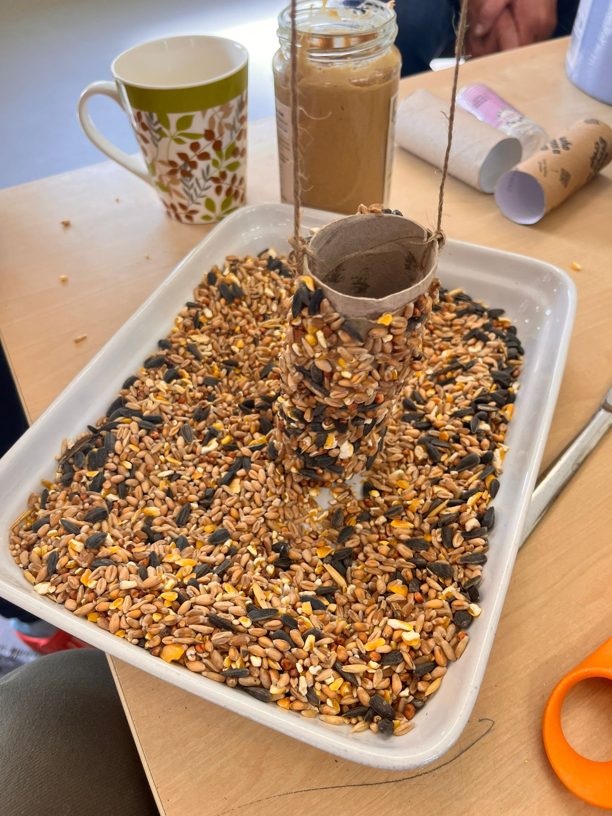
We’re making our own bird feeders earlier this year after sound advice from the Royal Horticultural Society. We’ll be following their guidance so we’re minimising cross contamination

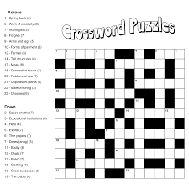
10th April 2027... Tabletop quiz morning
How’s your general knowledge? There will be simple crosswords, but also a host of other puzzles you might enjoy having a go at if you’re in the mood. Doing a puzzle with a group of friends is often so much more fun too and you can help each other succeed.

