Closing Prayers.
Trusting in the compassion of God, as our Saviour taught us, so we pray.
All Our Father in heaven, hallowed be your name, your kingdom come, your will be done, on earth as in heaven. Give us today our daily bread. Forgive us our sins as we forgive those who sin against us. Lead us not into temptation but deliver us from evil. For the kingdom, the power, and the glory are yours now and forever. Amen.

In peace we will lie down and sleep;
All for you alone, Lord, make us dwell in safety.
Abide with us, Lord Jesus,
All for the night is at hand and the day is now past.

As the night watch looks for the morning,
All so do we look for you, O Christ.
Come with the dawning of the day
All and make yourself known in the morning light.
May God bless us, that in us may be found love and humility, obedience and thanksgiving, discipline, gentleness and peace. Amen.

St Cuthbert’s &
The Annunciation
Eco Lent 2021

The Sessions this year are based around the book “Saying YES to Life”
By Ruth Valerio

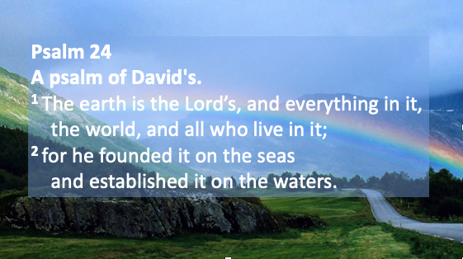

We will be meeting together every
Wednesday at 7:30 pm on zoom
throughout the season of Lent.

Reading and Meditations for Lent 2021:

Opening prayer:
Almighty Father, as we share this time together open our eyes to the wonders of your creation, guide us in this season of Lent to more fully appreciate your world and how creation speaks to our hearts, and soul about how wonderful you are. May your holy spirit help us to change our ways so that we look after your world more carefully. Amen

Tuesday 16th February 6:30pm: (Children welcome)
Pancakes at the Vicarage by Zoom. What’s your favorite pancake topping?

1st Week: Wednesday 17th February 7:30pm

Ash Wednesday service and an Introduction to Eco Lent and our book “saying YES to Life”

(Psalm 24) – Health

2nd Week: Wednesday 24th February 7:30pm
Let there be light …

(Genesis 1: 1-5) - Energy

3rd Week Wednesday 3rd March 7:30pm

Let the waters be separated…

(Genesis 1: 6-8) - Water

4th Week: Wednesday 10th March 7:30pm

Let the land produce vegetation…

(Genesis 1: 9-13) - Food

5th Week: Wednesday 17th March 7:30pm

Let there be light in the sky…

(Genesis 1: 14-19) – Pollution

6th Week: Wednesday 24th March 7:30pm

Let the waters team with living creatures and let birds fly…

(Genesis 1: 20-23) - Plastic

EARTH HOUR Saturday 27th March 8:30pm
Switch off all lights for 1 hour at 8:30pm

7th Week: Wednesday 31st March 7:30pm (Holy Week)
Let the land produce living creatures and let us make mankind in our image

(Genesis 1: 24-31) – Education

Saying yes to life lifts are focus from natural everyday concerns to issues that have an impact on millions of lives around the world. As people made in the image of God we are entrusted to look after what he has created: to share in Gods joy and ingenuity in making a difference for good. Justin Welby

