Prayer knots

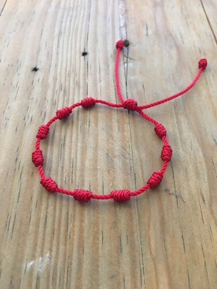
@ Church family

@Neighbourhood

@Family & friends

@Key workers & Carers

@World leaders

@Ourselves

Like worry beads, prayer knots are intended to help us manage our worries – when we find ourselves getting stuck in a state of anxiety and worry, focussing on all the ‘what ifs’ and the fears of what tomorrow may or will bring, we can have our prayer knots to hand and, instead, with a prayerful heart place them all into our Heavenly Father’s hands, each time these feelings threaten to overwhelm us.

They also help us to become focussed prayer warriors
They turn our focus away from us and onto those who really need our prayers.
Prayer always makes a difference to us and to others – we don’t always know how but we can leave that with God.

It can be something you do specifically at either end of the day or for a couple of minutes when things are called to mind. Some people turn the beads into a bracelet, so they have a sense of prayerfulness throughout the day.

‘Prayer leads us forward in hope.’
Pope Francis

