The Annunciation, South Kenton
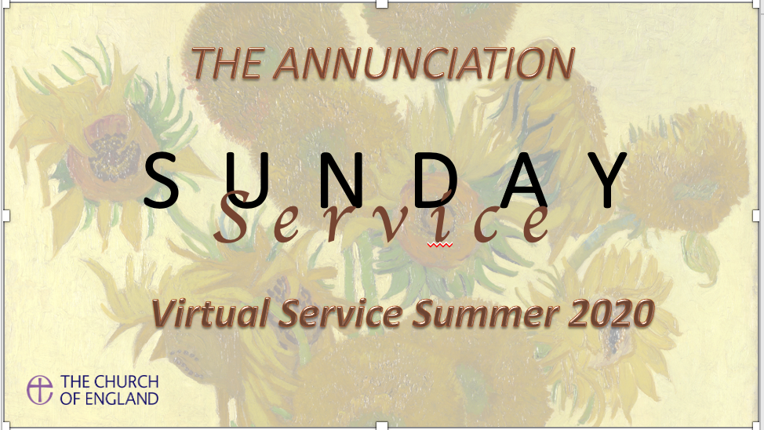

Holy Communion.

The Greeting

The president greets the people and Introduces the first hymn.

First Hymn: (See Screen)

Opening Prayer:
Faithful God, whose word is life: come with saving power
to free our praise, inspire our prayer and shape our lives
for the kingdom of your Son, Jesus Christ our Lord.
All: Amen

Invitation to Confession
Jesus says, ‘I am the light of the world. Whoever follows me shall not walk in darkness but will have the light of life.’ Let us then bring our secret sins into his light and confess them in penitence and faith.

All: Father eternal, giver of light and grace,
we have sinned against you
and against our neighbour, in what we have thought, in what we have said, in what we have done
And in what we have not done.
We have not loved you with our whole heart
we have not loved our neighbours as ourselves. we are truly sorry and turn away from what is wrong.
For the sake of your Son,
Jesus Christ, who died for us,
forgive us all that is past;
and lead us out from darkness
to walk as children of light. Amen.

Absolution
May God who loved the world so
much that he sent his Son to be our

Saviour, forgive you your sins and make
you holy to serve him in this world,
through Jesus Christ our Lord and saviour.

All: Amen.

First Readings:

This is the word of the Lord.

All: Thanks be to God.

Hymns: (See Screen)

Gospel Reading:

When the Gospel is announced the reader says

Hear the Gospel of our Lord Jesus
Christ according to Matthew

All: Glory to you, O Lord.

At the end
This is the Gospel of the Lord.

All: Praise to you, O Christ.

Talk.

Prayers:

The Peace
Introduction to the Peace,
We are the body of Christ. In the one Spirit we were all baptized into one body. Let us then pursue all that makes for peace and builds up our common life.

The peace of the Lord be with you

All: and also with you.

Let us offer one another a sign of Christ’s peace.

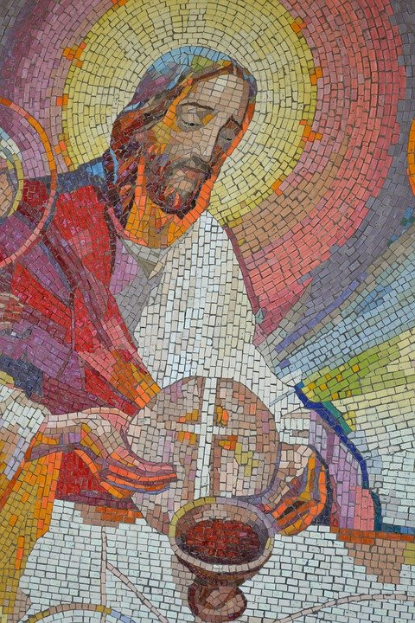

The Eucharistic Prayer
Father, in Christ there has sprung up a light for the righteous; accept the offering of your Church and grant that Christ may shine in us to the praise
and glory of your name.

All: Amen.

The Lord be with you

All: and also with you.

Lift up your hearts.

All: We lift them to the Lord.

Let us give thanks to the Lord our God.

All: It is right to give thanks and praise.
Father, you made the world and love your creation.
You gave your Son Jesus Christ to be our Saviour.
His dying and rising have set us free from sin and death.
And so we gladly thank you,
with saints and angels praising you, and saying:

All: Holy, holy, holy Lord, God of power and might,
heaven and earth are full of your glory.

Hosanna in the highest.

Blessed is he who comes in the name of
the Lord. Hosanna in the highest.

Please Sit
We praise and bless you, loving Father, through Jesus Christ, our Lord;
and as we obey his command, send your Holy Spirit,
that broken bread and wine outpoured may be for us the body and blood of your dear Son. On the night before he died he had supper with his friends and, taking bread, he praised you. He broke the bread, gave it to them and said: Take, eat; this is my body which is given for you;
do this in remembrance of me. When supper was ended he took the cup of wine. Again he praised you, gave it to them and said:
Drink this, all of you;
this is my blood of the new covenant,
which is shed for you and for many
for the forgiveness of sins.
Do this, as often as you drink it,
in remembrance of me.
So, Father, we remember all that Jesus did,
in him we plead with confidence his sacrifice
made once for all upon the cross.
Bringing before you the bread of life and cup of
salvation, we proclaim his death and resurrection
until he comes in glory.

Great is the mystery of faith

All: Christ has died:

Christ is risen:

Christ will come again.

Lord of all life,
help us to work together for that day
when your kingdom comes and
justice and mercy will be seen in all the earth.
Look with favour on your people,
gather us in your loving arms
and bring us with all the saints
to feast at your table in heaven.
Through Christ, and with Christ, and in Christ,
in the unity of the Holy Spirit,
all honour and glory are yours,
O loving Father, forever and ever.
All: Amen.

The Lord’s Prayer
As our Saviour taught us, so we pray
All: Our Father who art in heaven,
hallowed be thy name,
thy kingdom come;
thy will be done;
on earth as it is heaven.
Give us this day our daily bread.
And forgive us our trespasses,
as we forgive those who trespass against us.
And lead us not into temptation
but deliver us from evil.
For thine is the kingdom, the power,
and the glory, for ever and ever. Amen.

The president breaks the consecrated bread.
We break this bread
to share in the body of Christ.

All: Though we are many, we are one body,
because we all share in one bread.

The invitations to communion
Jesus is the Lamb of God
Who takes away the sin of the world.
Blessed are those who are called to his supper

Lord I am not worthy to receive you,

But only say the word and I shall be healed

Giving of Communion
If you do not wish to receive Holy Communion please feel free to come up and bow your head to receive a blessing.

Reflective music during communion:

Prayer after Communion

The Post Communion prayer

All: Almighty God,
we thank you for feeding us
with the body and blood of your Son

Jesus Christ. Through him we offer
you our souls and bodies to be a living sacrifice. Send us out
in the power of your Spirit
to live and work
to your praise and glory. Amen.

Notices:

Final Hymn: (See Hymn Board)

May the God of all hope give you a confident faith
and fill you with peace and true Compassion for
your neighbour. And the blessing of almighty God
the Father the Son and the Holy Spirit
be with you and remain with you always

All Amen.

Go in peace to love and serve the Lord.

All: In the name of Christ. Amen.

Picture Royalty free: sunflowers by Vincent Van Gogh.

